# 

# 

KATHIR COLLEGE OF ARTS AND SCIENCE

## BSC COMPUTER SC IENCE

Project Title :CRM Application for jewel management

Role :Developer

College code :BRUAH

Team Leader :Menaga V

Team member : Benat Asha A

Team member : HaripriyaT

Team member : Monika K

Mentor : Infant Angel Mam

**ABSTARCT**

The CRIB Application for Jewel management is a Salesforce-based solution designed to streamline jewelry business operations, including customer management, inventory tracking, billing, and sales. By, creating custom objects, fields, record types, and roles within Salesforce, the system provides an efficient, secure, and user-friendly platform. This project was developed as part of the **B.Sc. Computer Science** curriculum to gain hands-on experience in CRf•1 application development and teamwork.

The Jewel inventory System is a comprehensive software Solution designed to Streamline and manage the inventory and sales processes of a jewellery store or a solution to track and control the inventory of various jewellery items, maintain accurate records, and facilitate seamless sales transactions.

**As a team We've learned,**

* Real Time Salesforce Project
* Data Modelling
* Creating an Application
* User Interface Customization
* Object & Relationship
* Fie Id Dependencies
* Record Types
* Cross Object Formula
* Flows
* Reports & Dashboards
* Validation Rules
* Formula Fields

# INTRODUCTION

Customer Relationship Management(CRM) is a software approach that helps businesses manage their interactions with customers efficiently. In the jewelry business, handling customer details, sales transactions and inventory manually is time-consuming and prone to errors. To solve this problem, our team developed a CRI'•I Application for

Jewel management using salesforce. The main objective of this project is to automate customer management, maintain jewelry stock, process billing accurately and provide secure role-based access.

Why Jewel Business Needs CRM?

The Jewelry Business deals with high-value items, loyal customers, and frequent custom orders. Managing these manually often leads to errors, delays, or loss of customer trust. A CRM system helps jewel business by:

* Customer Relationship f•1anagement
* Sales & Billing
* Data Security
* Reports & Insights
* Inventory Tracking

## OBJECTIVES

 To develop a CRM application for jewelry business using

Salesforce

 To maintain accurate records of customers and their purchase

history

 To manage jewelry stock and update inventory in real time

 To automate sales and billing processes to reduce manual

errors.

 To implement roles, profiles and validation rule for secure

access.

 To provide dashboards and reports for better decision-making.

 To create a user-friendly interface for both admin and staff.

## SYSTEM REQUIREMENTS

Software Used

« Browser (Chrome/Edge)

* + Internet Connection
  + Salesforce Developer Org



Hardware Used

* Laptop with 4GB+ RAM
* Windows 10/11

# SYSTEM DESIGN

Architecture Diagram

User •3 Salesforce CRM •3 Database •3• Reports

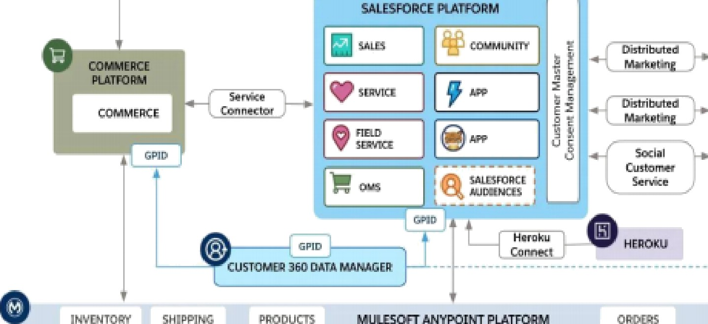Ï ceio

CKTOUERS

OBJECT CREATION

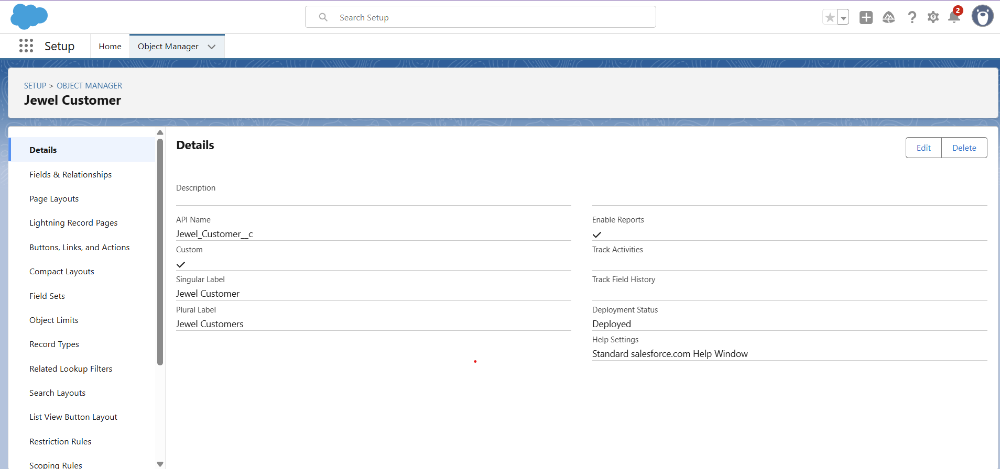

TABS

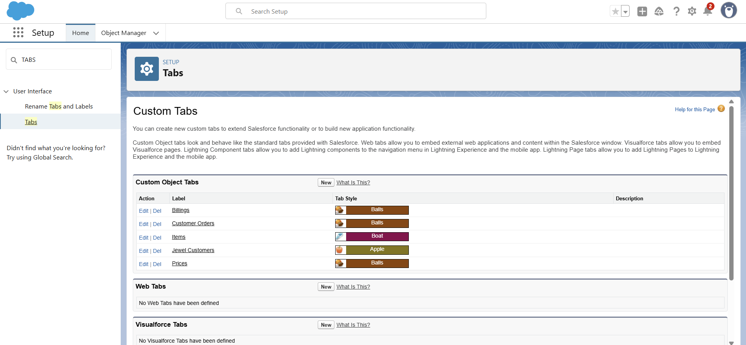

THE LIGHTNING APP

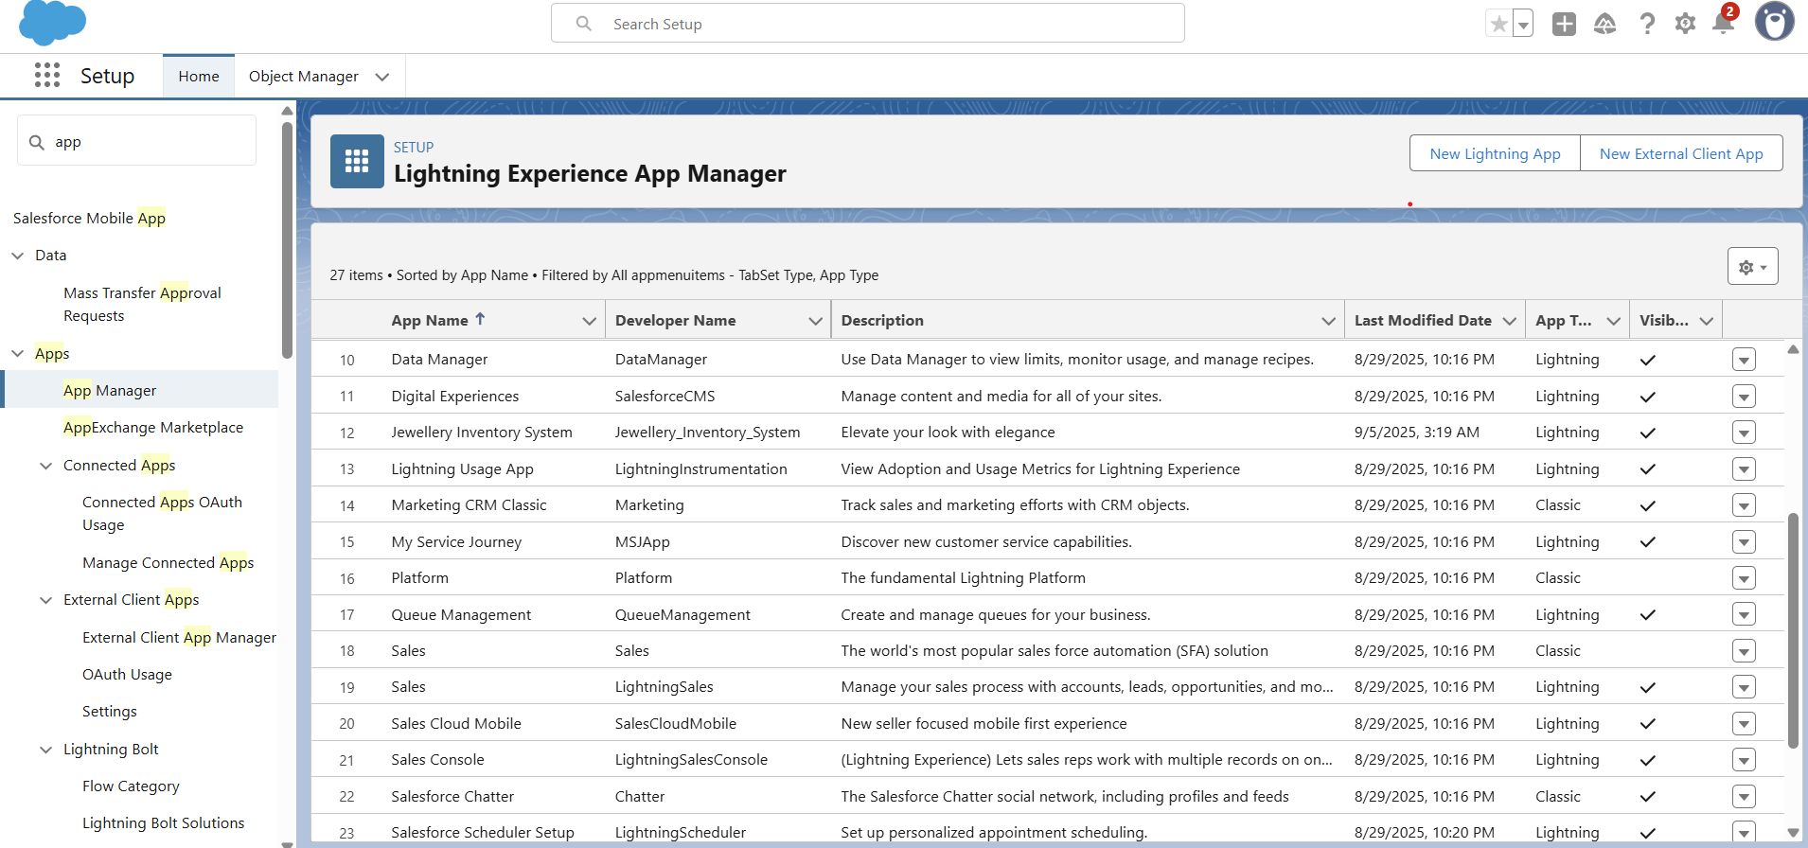

FIELDS

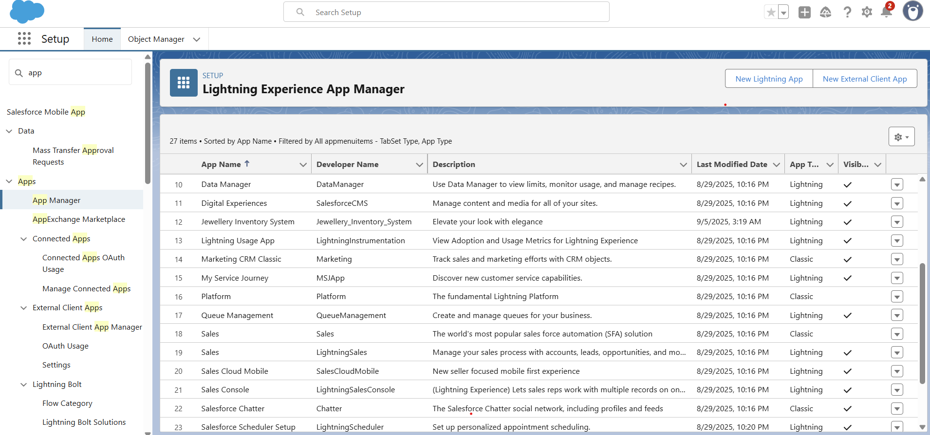

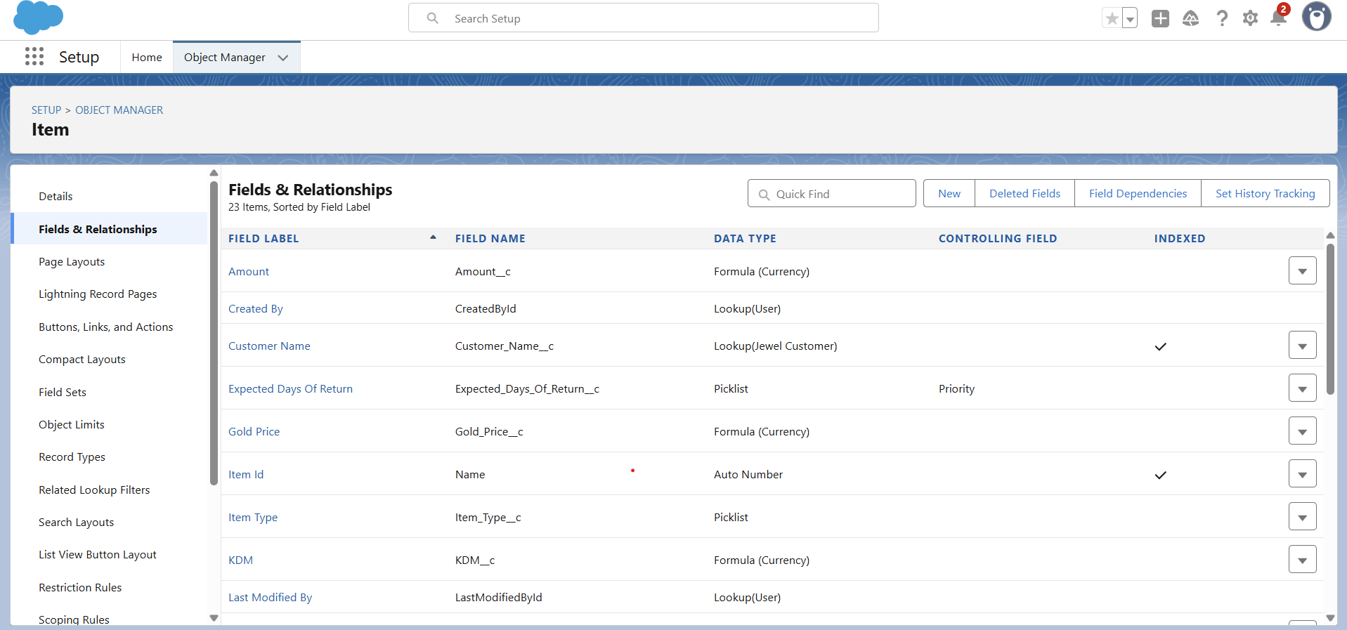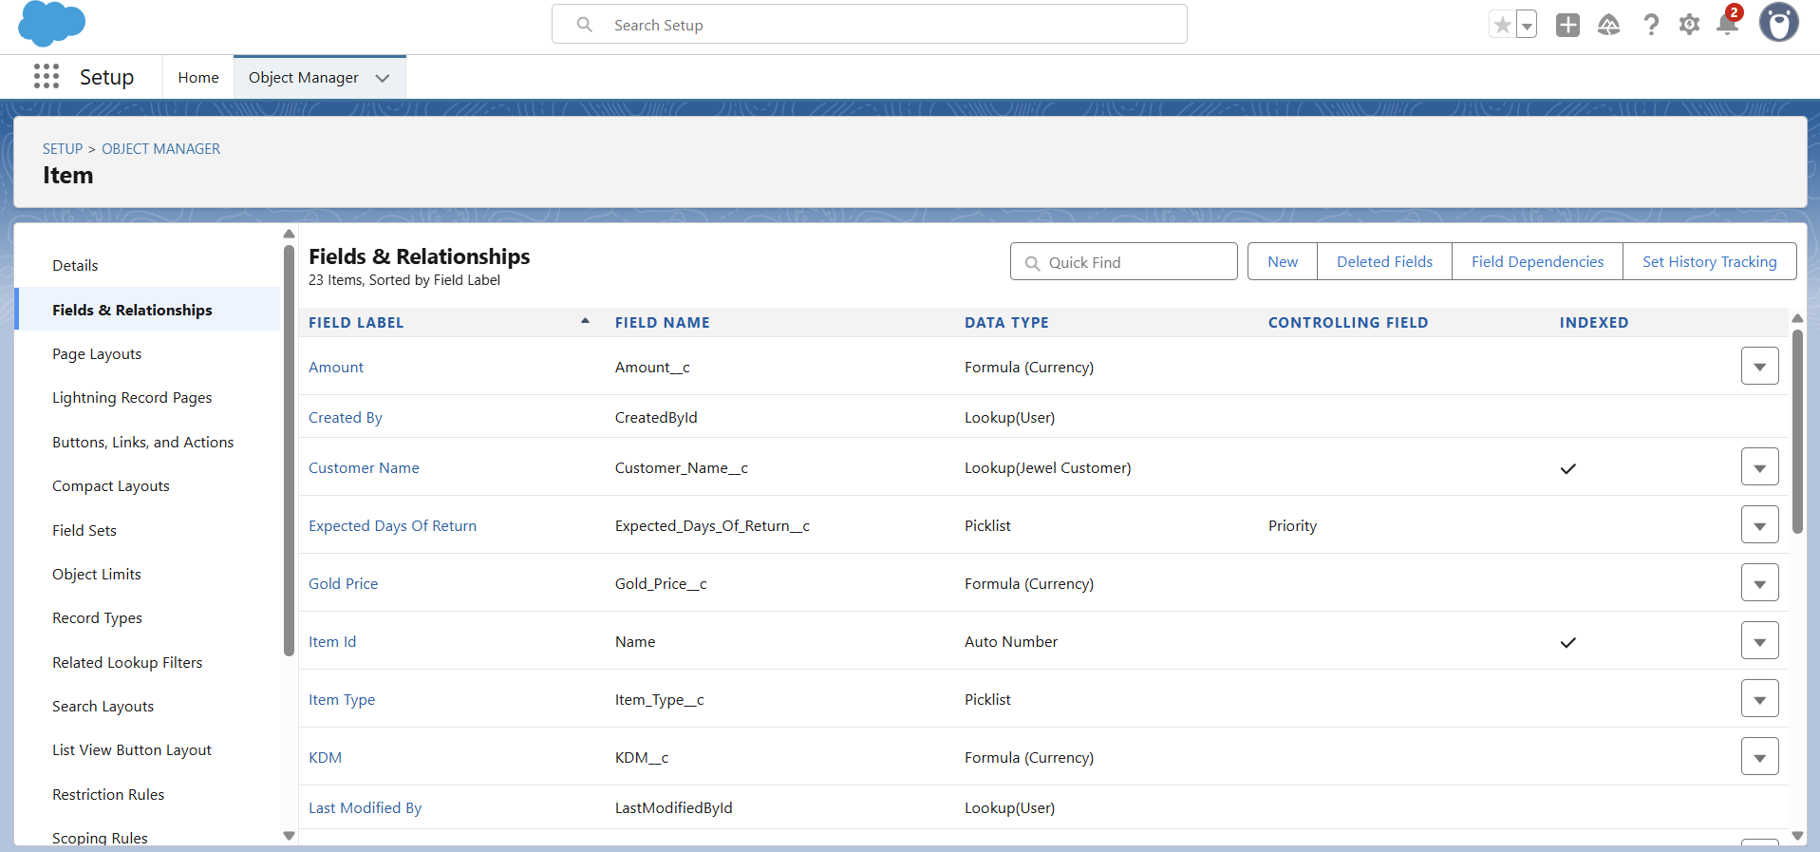

PROFILES AND USERS



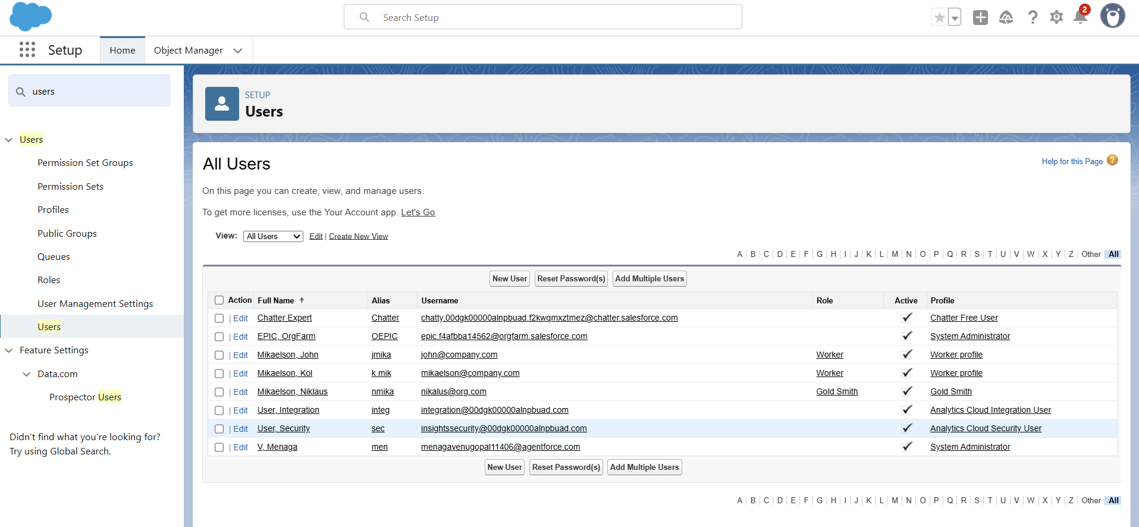

PAGE LAYOUTS AND RECORD TYPES

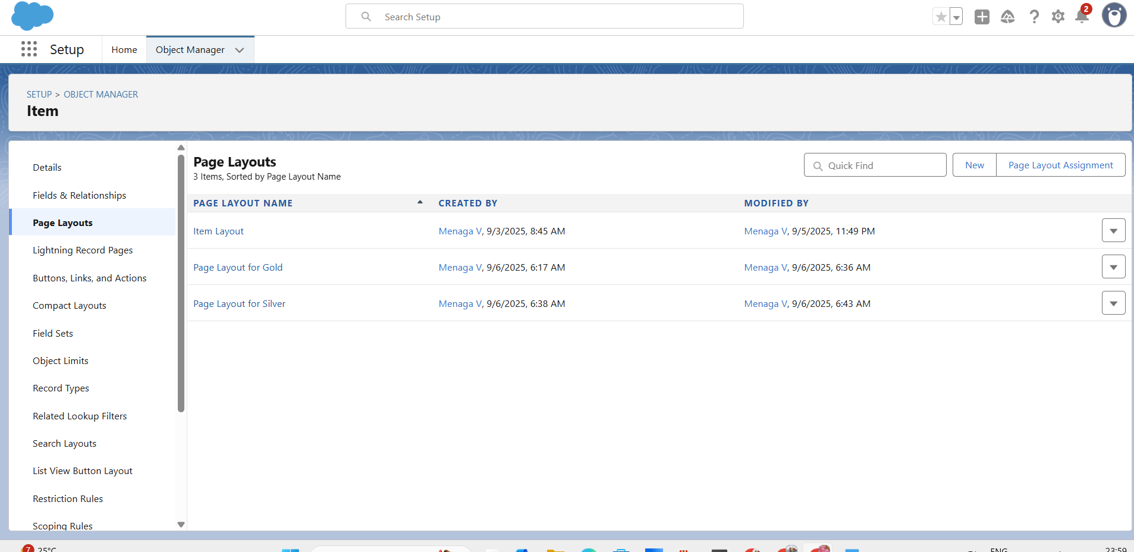

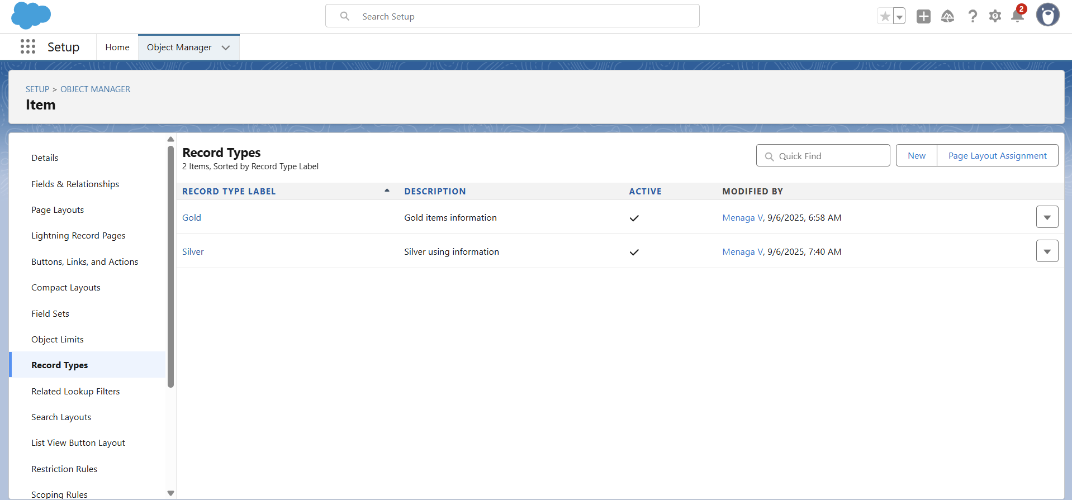

PERMISSION SETS

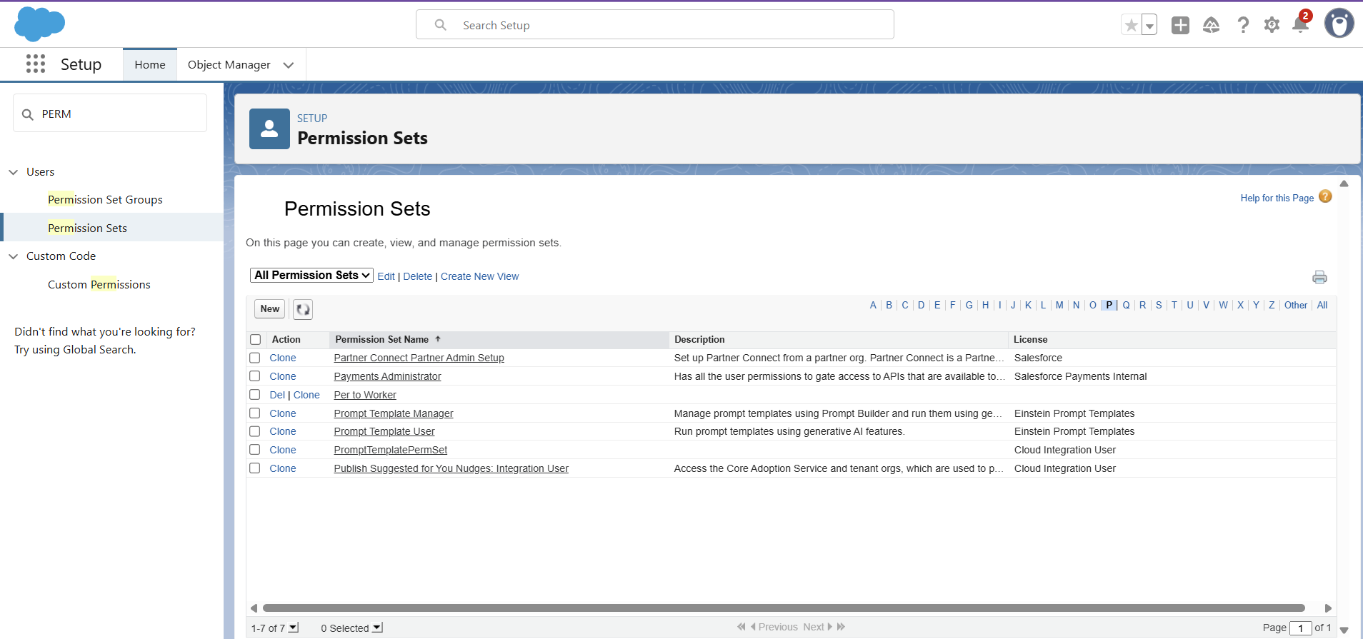

REPORTS AND DASHBOARDS

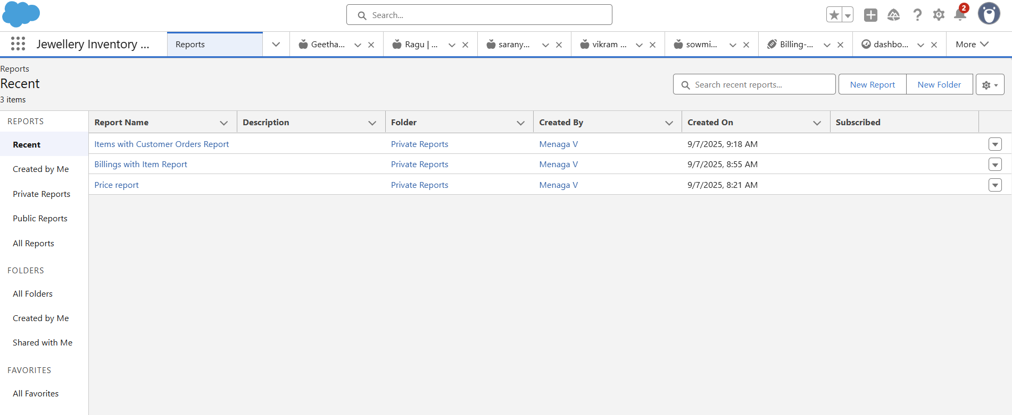

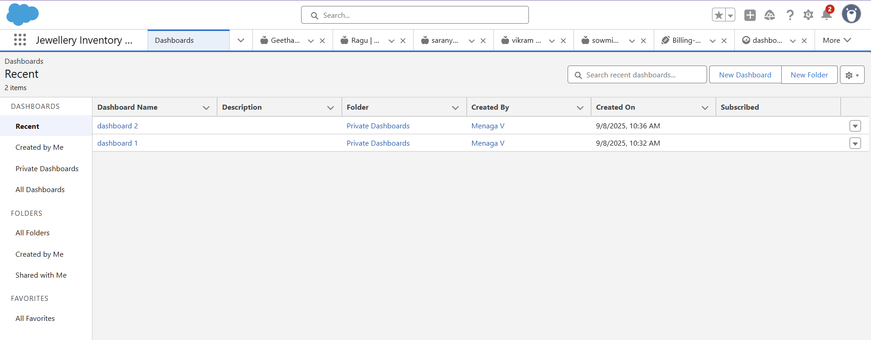

CONCLUSION

The CRM Application for Jewel Management was successfully developed on Salesforce. It manages customers, inventory, and sales efficiently, reducing manual errors. The project gave out team practical experience in CRM Application development, teamwork, and problem- solving.